1 Area of idea

Type: Platform
Function Area: All

2 Problem/Opportunity
The problem today:
When you jump into the cloud, the unique security risk will be entitled as well. The sensitive data will be processed outside of the enterprise network. And also the system will be exposed to the Internet. The system may be hacked by hacker via loopholes of the system applications and 3rd party applications.
• Lots of untrusted 3rd party applications are usually not bug free and have significant security concerns. The untrusted program or applications should be granted the most restrictive collection of capabilities required to perform its permitted duties and no more.

• Before going to cloud, lots of applications don’t need to consider the security problem; however running in the cloud is another story.

Existing technologies:
There are lots of existing technologies to help the security computing environment setup. However each technique is usually to solve one kind of security problems, there is no integrated solution, especially for the applications in the cloud.

• Chroot
Chroot is to switch a safe directory structure to make sure the system safety not impacted by the untrusted applications. When you change root to another directory you cannot access files and commands outside that directory. However there are lots of technologies to break out of the chroot jail.

• Dropping privilege
A better approach is to drop your root privilege at the very beginning of the application and regain it only in those parts of the code that need to run with increased privilege. This temporary dropping privilege is useless in case of arbitrary code execution where attackers have full control of the application via stack overrun, revertible.
Dropping privilege permanently after initialization would be an even better approach; however not all the applications are suitable for such case, especially for the ones need root privilege when running.

• Setuid
A program is installed setuid because it requires special/root privilege to operate system resources, such as raw socket, module injection etc. (The setuid bit in the file’s permission mask, which is property of the file system). This ‘s’ bit on your system will increase the risk to the security. So the setuid applications must be the trusted applications. However the trusted applications with s bit set will have the root effective user id, if this application is hacked, then root privilege will be got.

• Seccomp
Process is privilege boundary; system call is the mandatory interface to the system. Seccomp allows a process to do a one-way transition via PRCTL into a secure mode. In the secure mode, the process can’t execute system calls except the exit, sigreturn, read and write to already opened file descriptors. Otherwise the process will be terminated by the system via SIGKILL.
It is usually used for sandboxing for some applications, but not a system level security. Also only four system calls is supported, which is quite limited.

• Capability
There is no possible privilege separation inside a process. Linux capability provides one way to divides the privileges of root into distinct units, which can be enabled/disabled dynamically.
exec API can help to get all the capabilities again if hacker got arbitrary code execution.

Opportunity:
We propose to setup an integrated security computing environment for the applications in the cloud by limiting the running privilege and reducing the security risk by restricting the system call to the operating system of the 3rd party untrusted applications and system applications.

3 The idea
Firstly we don’t expose the root privilege. Only normal user privilege provided for the access to the system.

We have trusted setuid applications helper to setup the security computing environment, which has root effective uid and drop privileges permanently after initialization of the security environment.

The setuid security helper application will help to setup a security environment and bring up trusted or untrusted applications in it, setup its access privileges (chroot, newpid, setuid, drop privilege and system call white list) basing on the config file specified by the admin and monitor their status. The trusted or untrusted applications may run in a separate child process via fork or in the same process with the helper via exec.

All the existing or new developed applications or 3rd party applications don’t need to change any code (of course they can integrate the security computing environment into it tightly coupled via library, but most don’t do this).

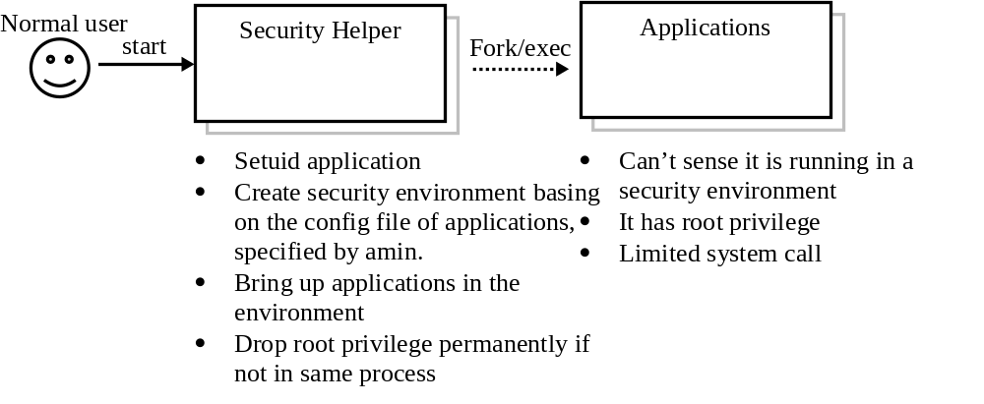
4 Business Case / Benefit vs Cost
• It is an userland framework
• No need to modify the conventional applications and 3rd party applications
• No performance overhead
• No modification of the kernel
• Using exiting technologies

5 Implementation Proposals
From the outside of the system, only a normal privilege user and a security helper application with setuid root privilege. The applications and 3rd party applications may be with root or any kinds of permissions to execute.

Security helper application will read the config file of the application to be booted, which is specified in XML format by system admin and only has root access permission. Basing on the configuration information, helper will setup a security environment.
• It may chroot to another directory to hide all the other system files.
• It may fork a new process with a namespace, which limit the process to trace outside.
• It may setuid
• It may drop the root privileges.
• It may limit the system call by secomp extension.
• It may help to config the Linux capability

The exec family of functions replaces the current process image with a new process image. Fork is used to create a child process.

